The Labour History Society SA
Invites you to hear
Dave Kirner
“The role of union members in engagement in environmental activism”
2.30 pm Sunday 19 August 2018
(immediately after AGM at 2pm)
Box Factory 59 Regent Street South, Adelaide.
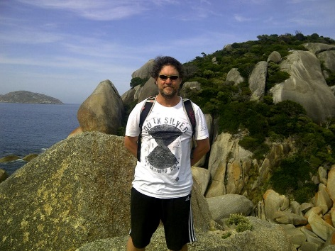

Dave Kirner began his activism in student and community politics in the early 1980s. He has been a union official for 31 years. Dave is currently State Secretary of the SA District & Assistant Secretary of Construction Forestry Mining and Energy Union (CFMEU) SA and a National Divisional Vice President of the Manufacturing Division of the CFMEU.
In his time as an activist in the union movement, Dave has worked for the Federated Furnishing Trades Society of Australasia; the Operative Painters and Decorators Union; the Victorian Trades Hall Council; and the CFMEU.
Dave attracted recent media attention when he was fined by the Federal Court for going onto a building site to discuss suicide prevention with members.
Dave Kirner has been an activist and campaigner in environmental issues, including as a member of the Friends of Sceale Bay:- campaigning for publishing protection for sea lion colonies in the area and resultant marine parks and conservation parks.

All welcome – free event - no bookings necessary – afternoon tea provided.
Enquiries: Jude Elton at jude.elton@internode.on.net

